The behavior of Ocean Waves

Student’s Name
Institutional Affiliation
Course Name and Number
Instructor’s Name
Assignment Due Date

1. After engaging the simulation, the waves resemble a rope being displaced from up to down. The wave has a resulting reverse wave which is re-propagated in a way from the opposite side that it accurately retraces its wave path back to the source. This wave is called a longitudinal wave.
2. The first wave has a smooth pattern compared to the second one which has an erratic wave pattern characterized by sharp corners at the peak of displacement. The wave also has a double ripple effect in that the wave path goes back to the source twice. These changes are attributed to a change in amplitude (0.7cm-1.25cm).
3. After increasing the wavelength from 0.50s to 1.00s, the wave displacement is increased compared to the first and second simulations where the displacement is minimal to none. In comparison, the third simulation has a higher displacement compared to the other two attributed to a change in wavelength.
4. The waves in simulations 1 to 3 do not exhibit any oscillatory motion. The oscillation in these three simulations is minimal hence difficult to note. In the 4th simulation, the wave takes 1.00 second to make a complete oscillation making the frequency of oscillation 1. This then translates to 1 complete oscillation in 1 second.
5. In ‘fixed end’, the reflected wave is inverted. The wave is re-emitted in an upside-down motion. When the wave is on a ‘no end’, it shares a similar path from where it originated due to the absence of a boundary.
6. The three end-types used in this simulation are, no end, loose end, and fixed end. With 'fixed end', the wave encounters a boundary (fixed end) and is reflected through the same path in an inverted trajectory. With 'no end, the amplitude of the wave decreases from the 5cm mark onwards. Finally, with 'loose end' towards the 7cm mark, the amplitude of the wave decreases with the same frequency. The ‘loose end’ exhibits the same path similarities as the ‘no end’. In all the above simulations, the wave peaks at the beginning at 4cm. When an ocean wave strikes the beach, it acts more with the vise striking the shore at an angle with parts closer to the beach (shallower parts) slowing down compared to the other parts. This bends the wave thereby creating refraction.
7. With the frequency at 1.5hz and an amplitude of 0.5cm, the wave on no end exhibits an acceleration after 10seconds of running, no apparent changes in motion is seen after 10 seconds. In the same measurements but with a fixed end, the wave changes path after 2seconds with a gradual increase in velocity towards the 10-second mark. The wave then flattens at 10 seconds and then picks up an oscillatory motion consistently then repeats the trajectory of motion after 22 seconds.
8. The pulse has a small displacement and a low velocity. The motion is reversed when the pulse reaches the vise, this is due to the refractory nature of a fixed end. The trajectory of the re-emitted pulse differs from the initial pulse.
9. Towards the course of 10 seconds, the wave flattens due to the addition of the top and bottom waves. The two waves oscillations at a given point are in the same direction but when it flattens, the waves experience an interference phenomenon where both waves achieve the same amplitude traveling in the same medium but opposite directions, one towards the vise and the other towards the oscillator.
10. The peaks of the wave match due to a similarity in amplitude after 5seconds of running. The two waves share the same velocity. The waves experience a constructive interference whereby the waves superimpose each other to share the same amplitude indicated by an equal displacement of the trough.

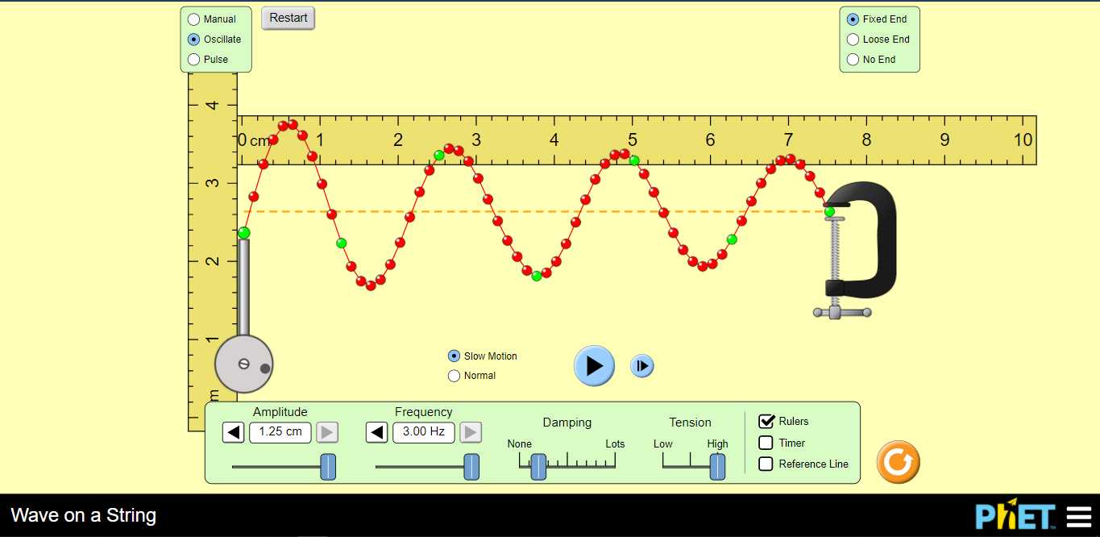
11. When the peak of the trough matches the peak of the crest, destructive interference occurs. When the maxima of the upper and lower waves are 180º out phase, a positive displacement on the upper wave is canceled by a negative displacement of the lower wave. Destructive interference results in an amplitude of zero (0).
